Phase 3

Total session 9

Spring framework and Spring boot, Unit testing, Rest full web service and micro service using Spring framework/spring boot

**Day 9**

3 or 2

Login

Emailed or username as pk

Password

Citizens table

cid 1 PK

cname Ravi

age 21

gender Male

mobile 9901122

city Bangalore

state Kar

pincode 560096

VaccinationCenter

VCId 100 101 PK

HCName HSBLayout Nandini Layout

Vcname 1st Vacicine, 2nd Vaccine

Dateandtime 20-Mar-2020 18-Dec-2022

cid 1 1 FK

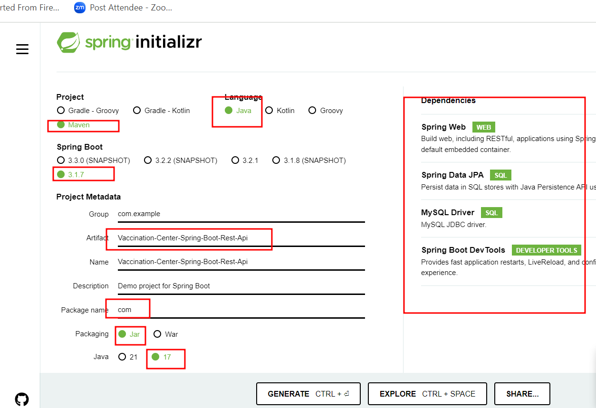

Micro service : we are developing small – small modules those modules we deploy independently.

Those modules can be develop using java or any other technologies. Database can be same or different. These micro service are communicating with each other via rest api call.

Spring boot provided eureka server which help to deploy more than one micro service created using spring boot.

1st step : we need to create spring boot project with eureka server and web starter to run eureka server.

2nd you need to create spring boot project as micro service project with eureka client and other starter like web, jdbc, jpa etc.

3rd you need to create spring boot project as micro service project with eureka client and other starter like web, jdbc, jpa etc.

4th you need to create spring boot project as micro service project with eureka client and other starter like web, jdbc, jpa etc.

Creating Eureka Server spring boot project

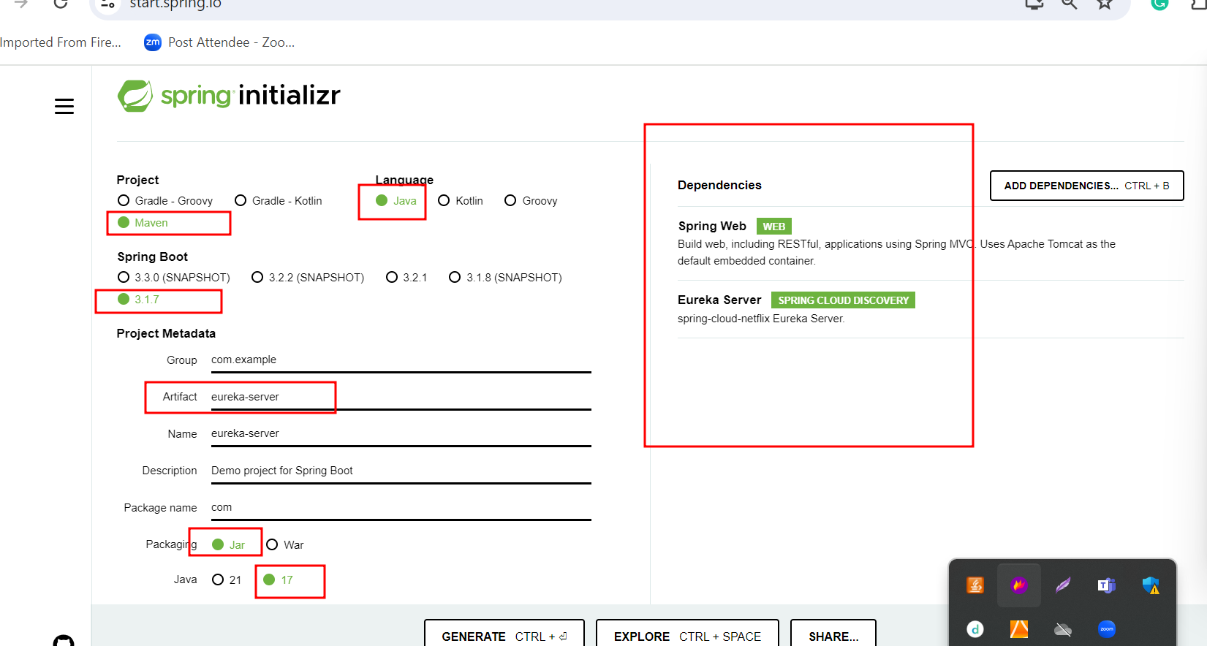

2nd you need to create spring boot project as micro service project with eureka client and other starter like web, jdbc, jpa etc.

Whenever we are going to deploy spring micro service project by default it will search on default port number of eureka server. By default eureka server port number is 8761

Now we need to create eureka client application with below starter

